**TERM PROJECT INTERIM PROGRESS - MARVELS**

**Subhiksha Ravichandran(G02495764)**

**Venkata Sai Kavya Kannedari(G02494113)**

**Kalijavedu Sahithi Reddy(G02492753)**

**Sai Sujith Areti(G02494574)**

**A Detailed Description of the Function**

* When a user accesses the application's main page and clicks the "Login" button, he will be prompted to enter his credentials before being taken to the app's home screen.
* When the application is started, a home page must be generated, and this page must have the opportunity to log in as well as information about the court reservation. To use the application, this data needs to be displayed.
* After logging in, it should start taking you to the home page. If we sign in as Admin, it should take us to the home page for admins. If we sign in as User, it should carry us to the home page for that user.

**Things need to be done to accomplish this task:**

1. To successfully store and verify user input in the database, you must first create a Class with the necessary attributes.
2. we have two ways to use the application: as an admin or as a user. The admin login can help add the number of courts and players, as well as change the locations in the application. Even though the user can see how to book a court , they can't change the application.
3. The application needs the User class and the admin class to be made. And set up the database for the application and ensure sure it has the appropriate mapping.
4. Create the user interface as well as the service methods for the controller in the backend.
5. Build the framework for the program and begin adding classes to the different layers.
6. Begin by developing a main class for the application and tagging its methods.
7. The project includes the Controller part as main code, that includes SPRING–MVC framework that is used to build the web applications. The HTTP requests and responses are managed from this Framework.
8. We need to make a class at the attribute level and make sure that the method lets us get to the database values. Whether it's an administrator or a regular user, you'll need to set up a condition in the database to ensure that their information is correct.
9. Maintaining the condition and navigating between user interface pages based on user input is the function of the controller class.

**Sign up Page:**

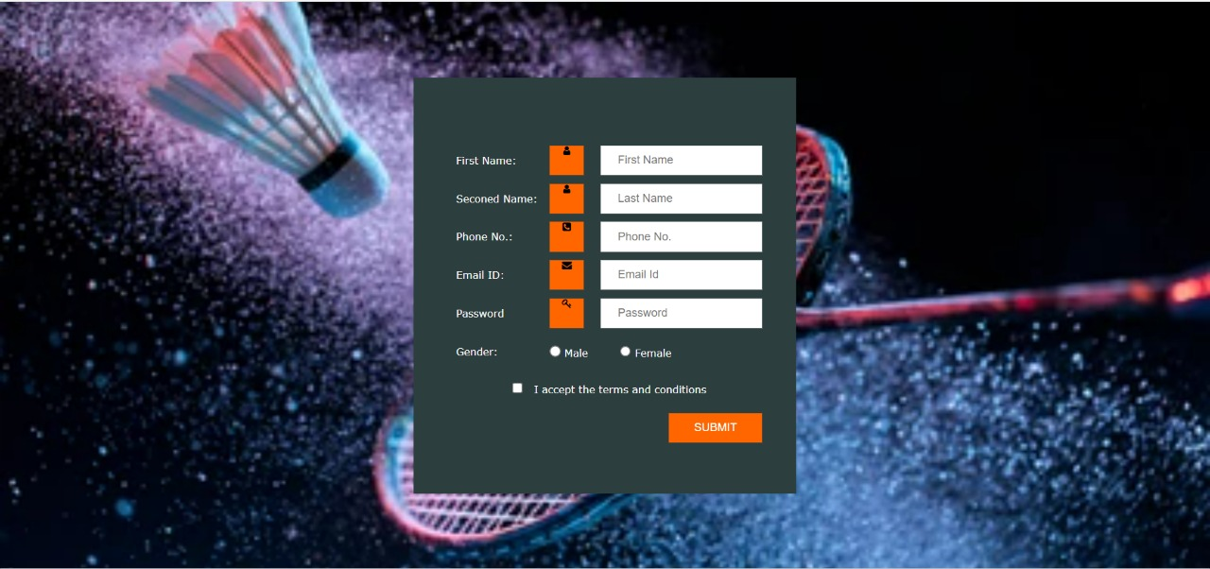

**Login Page:**

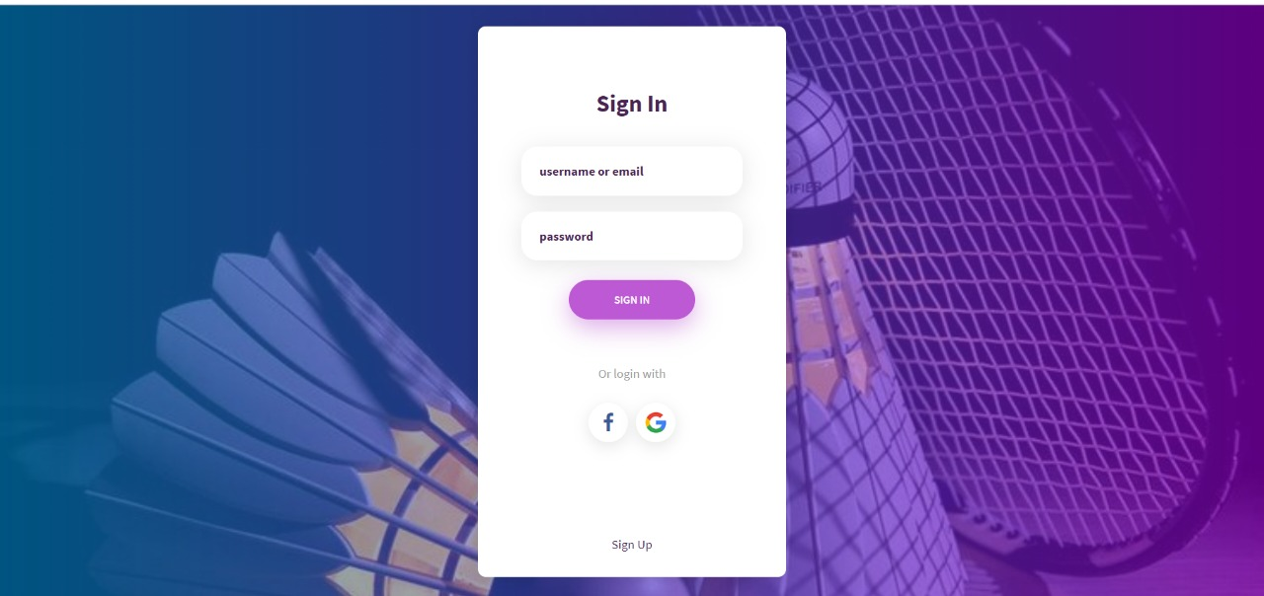

**Home Page:**

